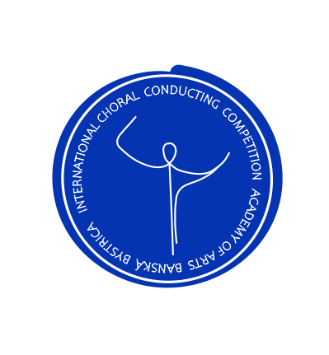
Encounters Over the Choral Scores

5th year of the international Conducting Competition

Application form

Name: ...........................................................................................................................................
Surname:.......................................................................................................................................
Date of birth:.................................................................................................................................
Email:............................................................................................................................................
Telephone number:.....................................................................................................................
City:..............................................................................................................................................
Country:........................................................................................................................................

Category (A or B): ......................................................................................................................
A selected composition of a contemporary (living) composer from the participant`s country:
.......................................................................................................................................................

-----------------------------------------------------------------------------------------------------------------Filled application form must be received NO LATER than 11. 4. 2021 at the following email address: dirigentskasutaz@gmail.com
If you need additional information please call: +421911578579 (english language)

A brief artistic biography of the contestant
(study, conducting experience, completed competitions, courses, cooperations, etc.)
approx. 10-15 phrases

